Chapter 1
Section 1.1

#2 a) True
b) False
c) False
d) True
e) True
f) False

#4 a) {1, 2, 3, 4, 5, 6, 7, 8, 9}
b) {-3, -2, -1, 0, 1, 2, 3}

#6 { x | x is a positive even integer less than twelve}

#8 { x | x = y³ and y ∈ {1, 2, 3, 4, 5}}

#22 a) False
b) True
c) Insufficient information
d) True
e) True
f) False

#28 a) { {}, {3}, {7}, {2}, {3, 7}, {3, 2}, {2, 7}, {2, 3, 7}}
b) 3
c) 8

#34 Choose any x ∈ A. Since A ⊆ B, x ∈ B. Also, since B ⊆ C, x ∈ C. Hence, any element
of A belongs to C, and A ⊆ C.

#36 Let b be the element of B that is not an element of A. Each subset of B either contains b or it does not. If a subset of B doesn’t contain b, then it is a subset of A. There are n such subsets. If a subset of B contains b, then it is the union of a subset of A and {b}. There are n such subsets. So there are 2n total subsets of B.

Section 1.2

#14 C ∪ (A ∩ B) is one possible answer

#16 |AB| = 7, |A| = 4, |B| = 5, |AB| = 2.
|AB| = |A| + |B| - |AB| and Theorem 2 is verified.

#30 245 juniors have declared their major.
388 sophomores and juniors have declared their major.
677 students have declared their major or are sophomores, but are not seniors.
Section 1.5

#12 AB = 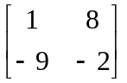

BA = 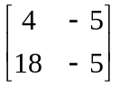

#38 a) a_{ij} = 0, because if a_{ij} = 1, it would force b_{ij} = 1.
a_{ij} = 1, because if a_{ij} = 0, it would force b_{ij} = 0.

b) a_{ij} = 0, because if a_{ij} = 1, it would force b_{ij} = 1.
a_{ij} = 1, because if a_{ij} = 0, it would force b_{ij} = 0.

Section 1.6

#18 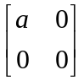∙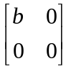 or 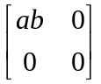 belongs to M.

#20 Yes, 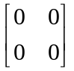 since 0 is a real number.

#22 If A = , then -A = 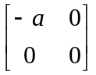. –a is also in the real numbers.

#24 Yes

#26 No

#28 No

#30 a) Yes, 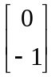
b) Yes, 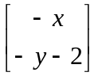

Chapter 2
Section 2.1

#12 a) p ^ ~ r
b) q v p
c) ~ p ^ ~ q
d) r ^ q

#18 a) 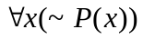
b) 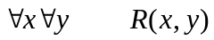
c) 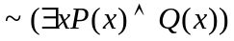
d) 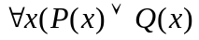

#28 p q p v q v ~q
T T T T F
T F T T T
F T T T F
F F F T T

#30 p q r (~p v q ) ^ ~r
T T T T F
T T F T T
T F T F F
T F F F F
F T T T F
F T F T T
F F T T F
F F F T T

#34 a)
p q p ∆ q
T T F
T F T
F T T
F F F

b)
p ~ p p ∆ ~p
T F T
F T T

Section 2.2

#6 a) ~ r => q
b) ~q ^ p
c) q => ~ p
d) ~p => ~ r

#10 a) absurdity
p ~p (p ^ ~p )
T F F
F T F

b) contingency
p q q v (~q ^ p )
T T T F
T F T T
F T T F
F F F F

#26 a) (i)
b) (iv)

#28 p q ~ (p ^ q) ~p v ~q
T T F T F F F
T F T F F T T
F T T F T T F
F F T F T T T
(A) (B)

Because columns (A) and (B) are the same, the statements are equivalent.

Section 2.3

#26 For n = 2, we have 1 + 4 > 9 , which is false. Thus, the statement is disproven.

Section 2.4

#6 Basis step: n = 1 P(1): 1 =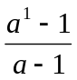 is true.

Induction step: Assume P(k): 1 + a + a² +….+ a^{k-1} = 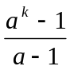

Then LHS of P(k + 1)

= 1 + a + a² +….+ a^{k-1} + a^{k}

= + a^{k}

= 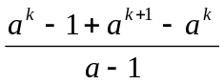

=

= RHS of P(k + 1)

#16 Basis step: n = 1 P(1): 3 | (1³ - 1) is true.

Induction step: Use P(k) : 3 | (k³ – k) to show P(k+1) : 3 | ((k+1) ³ – (k+1))

(k+1) ³ - (k+1) = k³ + 3k² + 3k + 1 – k – 1 = k³ – k + 3k² + 3k

Since 3 | (k³ – k) by the inductive assumption, and 3 | (3k² + 3k) because 3 is a factor of each term, 3 divides the sum of (k³ – k) and (3k² + 3k).

So, 3 | ((k+1) ³ – (k+1)) .

Chapter 3

Section 3.1

#2 120

#4 120

#8 a) 24
b) 720
c) 42

Section 3.2

#4 980

#20 a) 45
b) 21

Section 3.3

#18 There are ten pairs whose sum is 21. It is possible to choose 10 disks without producing one of these pairs.

Chapter 4

Section 4.1

#32 {{a},{b}, {c}, {d}}, {{a},{b, c, d}}, {{b},{a, c, d}}, {{c},{a, b, d}},
{{a, b, c}, {d}}, {{a, b}, {c, d}}, {{a, c}, {b, d}},{{a, d}, {b, c}},
{{a, b, c, d}}, {{a},{b}, {c, d}}, {{a},{c}, {b, d}}, {{a},{d}, {b, c}},
{{b},{c}, {a, d}}, {{b},{d}, {a, c}}, {{c},{d}, {a, b}}

Section 4.2

#2 a) Yes
b) No
c) Yes
d) No
e) Yes
f) No

#4 Domain: {a, b, c, d}
Range: {1, 2} 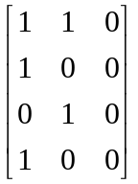

#6 Domain: {1, 2, 3}
Range: (1, 4, 9) 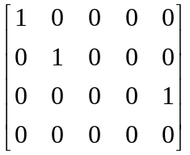

#8 Domain: {1, 2, 3, 4}
Range: (1, 4, 6, 9) 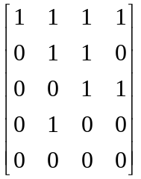

#10 Domain: {1, 2, 3, 4, 5}
Range: {1, 2, 3, 4, 5} 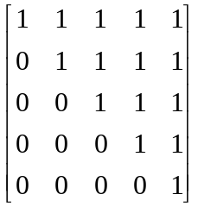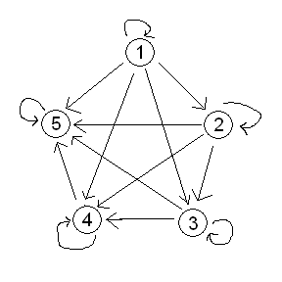

#12 Domain: {1, 2, 3, 4, 8}
Range: {1, 2, 3, 4, 8} 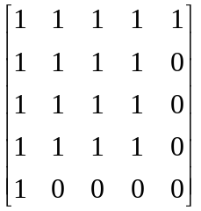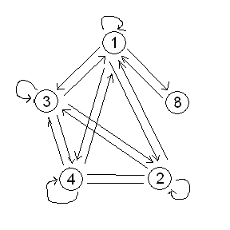

#14 Dom(R) = all reals
Ran(R) = all reals

#24 R = {(a, a), (a, b), (b, c), (b, d), (c, d), (c, e), (d, b), (d, c), (e, a)}
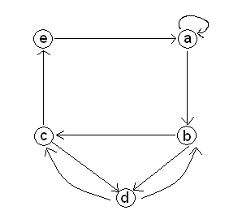

#26 R = {(1, 2), (1, 3), (1, 4), (2, 2), (2, 3), (4, 1), (4, 4), (4, 5)} 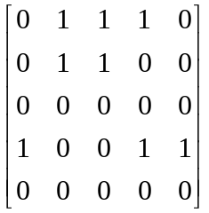

Section 4.3

#2 a) 2, 3, 3 2, 3, 4
b) 2, 3, 3 2, 3, 4 1, 6, 4 1, 2, 3
3, 3, 3 3, 3, 4 3, 4, 5 3, 4, 3
4, 3, 3 6, 4, 3 4, 1, 6 6, 4, 5
4, 1, 2 3, 4, 1 4, 3, 4 6, 4, 1

#4 One is 2, 3, 4, 1, 2

#6
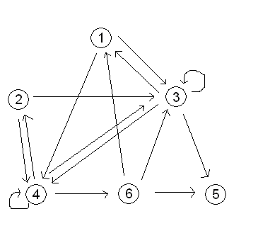

#8 a) {(1, 1), (1, 2), (1, 3), (1, 4), (1, 5), (1, 6), (2, 1), (2, 2), (2, 3) (2, 4), (2, 5),
(2, 6), (3, 1), (3, 2), (3, 3), (3, 4), (3, 5), (3, 6), (4, 1), (4, 2), (4, 3), (4, 4),
(4, 5), (4, 6), (6, 1), (6, 2), (6, 3), (6, 4), (6, 5), (6, 6)}

b) 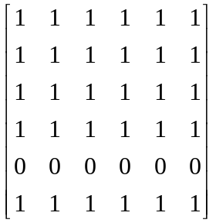

#10 a) c, e, f c, d, c c, d, b
b) a, c, d a, c, e a, b, b a, b, f, b, b, f
b, f, d b, b, b c, d, c c, d, b c, e, f
d, b, b d, b, f d, c, d d, c, e e, f, d
f, d, b f, d, c

#12 One is c, d, c

#14 No cycle can begin at a, since the in-degree of a is 0.

#16
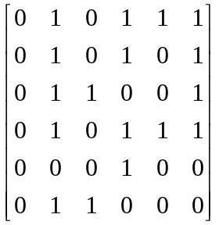 Yes

#20 1, 2, 4, 3, 5, 6, 4

#24 7, 4, 3, 5, 6, 7; 5, 6, 7, 5 are two of the possible answers

Section 4.4

#10 irreflexive, asymmetric, antisymmetric, transitive

#12 reflexive, symmetric, transitive

#34 Let R be symmetric. Suppose aR²b. Then there exists c ∈ A with aRc, cRb. Since R is symmetric, cRa, bRc and bR²a.

Section 4.5

#10 Yes

Chapter 5

Section 5.1

#24 no (a, 1), (a, 2) ∈ f ⁻¹

#26
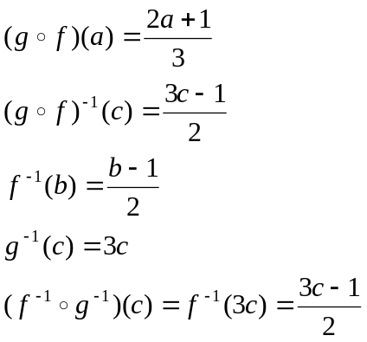

#28 n!

Section 5.2

#22 a) False
b) False
c) True

#24 a) 59
b) 128

#26 a) 47
b) 34
c) 44

Section 5.3

#12

f₅, f₇, f₄, f₈, (f₆, f₁₀, f₁₁), f₁₂, f₁, f₂, f₃, f₉

Chapter 7

Section 7.1

#24 Suppose vTv. Then there is a cycle in T. But this is a contradiction. Hence, v is never
related to v by T. T is irreflexive.

Section 7.3

#32
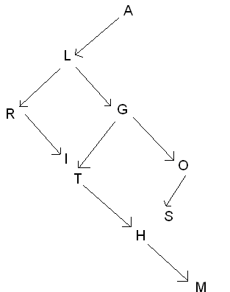

Chapter 8

Section 8.1

#14 Each vertex has degree n-1.

#16 Many such graphs are possible.

#18 Answers will vary.

#26 Each vertex in K_{n} has degree n-1. Thus, the total number of edges is n(n-1)/2 since each
edge is counted twice.

Section 8.2

#2 neither There are 4 vertices of odd degree.

#4 Euler path, no Euler circuit Exactly two vertices have odd degree.

#6 Euler path, no Euler circuit Exactly two vertices have odd degree.

#8 Euler circuit Zero vertices have odd degree.

#10 Yes, all vertices have even degree.

#12 Many possible answers.

#14 Yes.

Section 8.3

#2 Hamiltonian circuit ( a, b, c, d, a , for example)

#4 Hamiltonian circuit

#6 Hamiltonian circuit

#20 One simple example would be a rectangle with the four corners as vertices.

